Business Central (BC)
Quick Start Guide

Table of Contents
BC NAVIGATION 3
Login IN BC 4
To Log Out of BC 5
Landing page: The Role Center 5
Opening Companies 7
Help 8
In page help 9
Keyboard Shortcuts 10
“Tell Me to” Find Feature 10
Find an Action on the Current Page 11
Find a Page or a Task 11
Find a Report or Archived Information 11
Personalizing Your Workspace 12
How to personalize a page 12
What You Can Personalize 12
Personalizing Actions 14
Action Bar Overview 14
To remove, hide, and show actions and groups 15
To move actions and action groups 15
To clear personalization 15
Sorting, Searching, and Filtering Lists 16
Sorting 16
Searching 16
Fine-tune the Search 17
See Example Searches 17
Filtering 18
Working in the Filter Pane 18
Entering Filter Criteria in the Filter Pane 19
Entering Filter Criteria Without Using the Filter Pane 19
Filter Criteria and Symbols 19
Filter Tokens 21
(%me or %userid) Records Assigned to You 21
Entering Data 21
Data Entry Using Quick Entry Accelerates the Process 21
Tips and tricks 22
How to Change Quick Entry Fields 22
Mandatory Fields 23
Finding Data As You Type 23
Focus on Lines 23
Entering Quantities by Calculation 25
Entering Dates 25
Copying and Pasting 26
What you can copy 26
Lists that you can copy and paste rows 26
Viewing and Editing in Excel From Business Central 27
Open in Excel 27
Edit in Excel 27
Managing Notifications 27
To turn notifications on or off, and control when they are sent 28
Working With Reports 29
Specifying the Data to Include in the Report 29
Using Saved Settings 30
Previewing a Report 30
Scheduling a Report to Run 31
Add Comments to Cards and Documents 31
Send Documents by Email 31

BC NAVIGATION

Login IN BC

To log in to BC, enter your email address and password

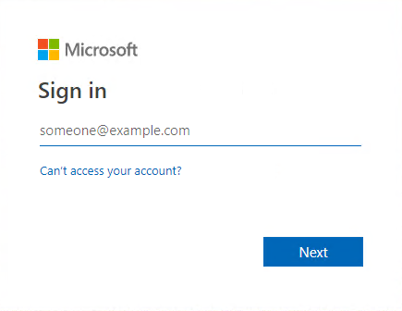

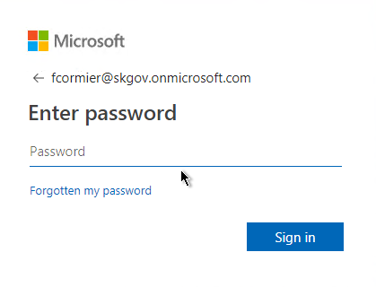

To Log Out of BC

Click on your name icon

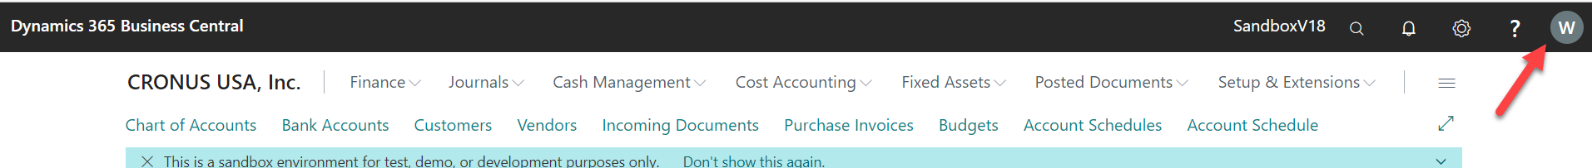

And then select Sign out

Landing page: The Role Center

The Role Centre represents the home page, a starting screen that is designed for the needs of a specific role in an organization. The contents of the role center are defined by your assigned job profile. Depending on your role, the Role Centre gives you an overview of the business, your department, or your personal tasks. It also helps you navigate to your daily tasks and find work that is assigned to you.

The assigned job profile is indicated in the web tab of your browser

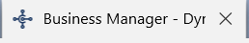

At the top, the navigation allows you to switch between customers, vendors, items, and other important lists of information. Similarly, actions allow you to initiate tasks, such as create a new sales invoice, directly from the Role Centre.

In the centre, you find Activities. Activities show current data and can be clicked or tapped to view more detailed information. Key Performance Indicators can be set up to display a selected chart for a visual representation of, for example, cash flow or income and expenses. You can also build up a list of favourite customers on the home page for accounts that you do business with often or need to pay special attention to.

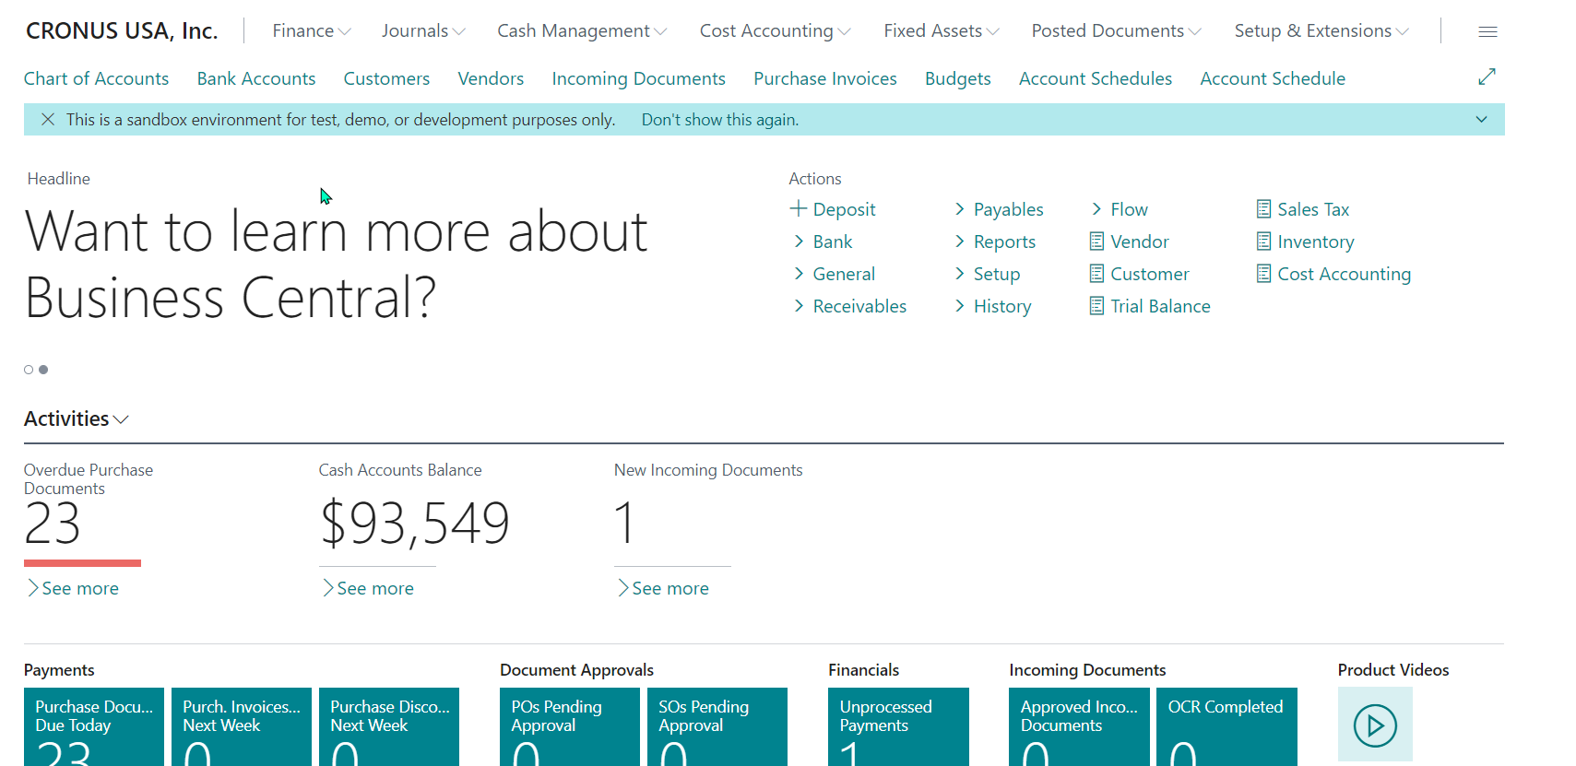

To return to this role center page once you’ve navigated to another page or list you can click on the company name at the top left of your screen.

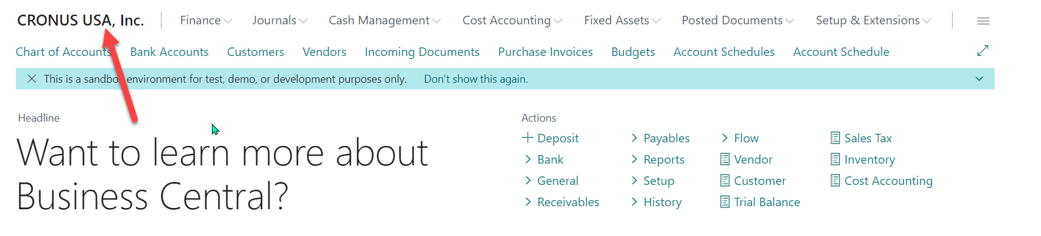

Opening Companies

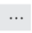
To Open Companies, click on the gear symbol at the Top right of your screen, then click My Settings, and go to the Company field, click on the Ellipsis and Select Company

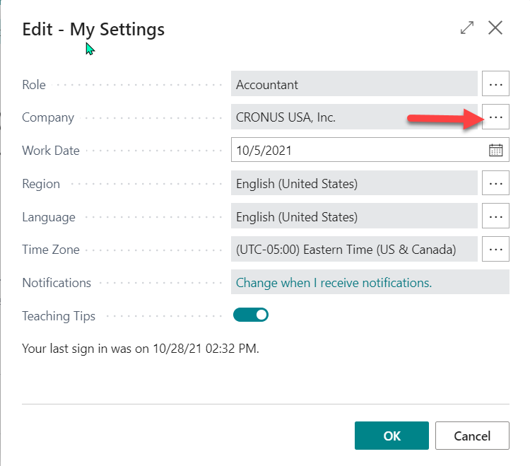

Note: The Select Company window will display all the available companies in your database.

Help

From the ‘Help’ button at the top right of the window

When you do this on the main application this option allows you to search through the entire database of help topics in order to find more information on a particular topic.

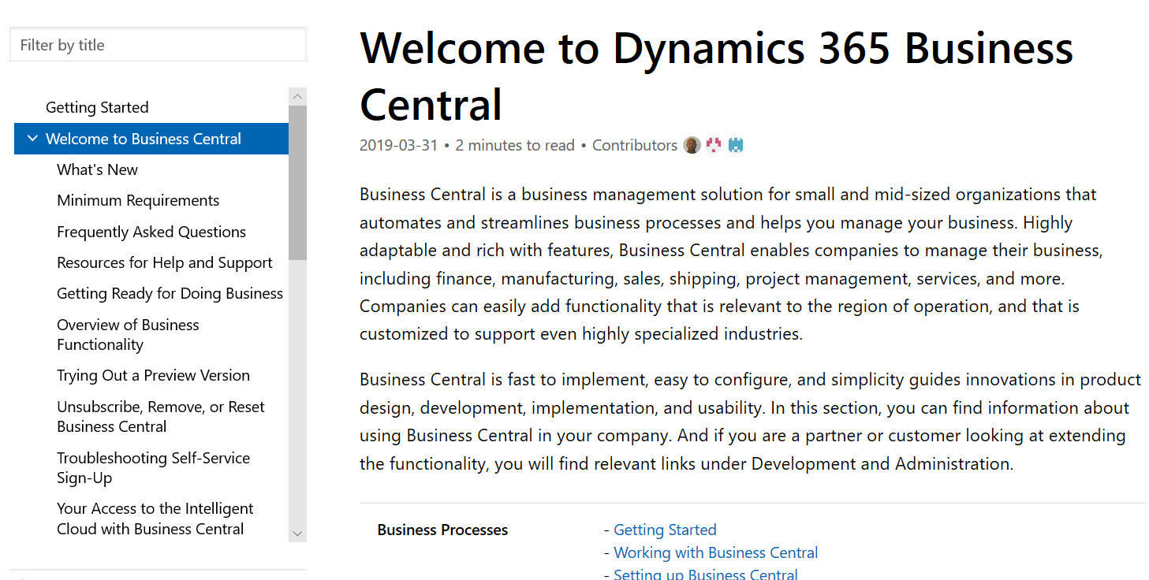

When this is done from an entity form (eg. sales order, item, etc.) this provides you with help specific to the current window but still gives you access to the system-wide application help if you require it.

In page help

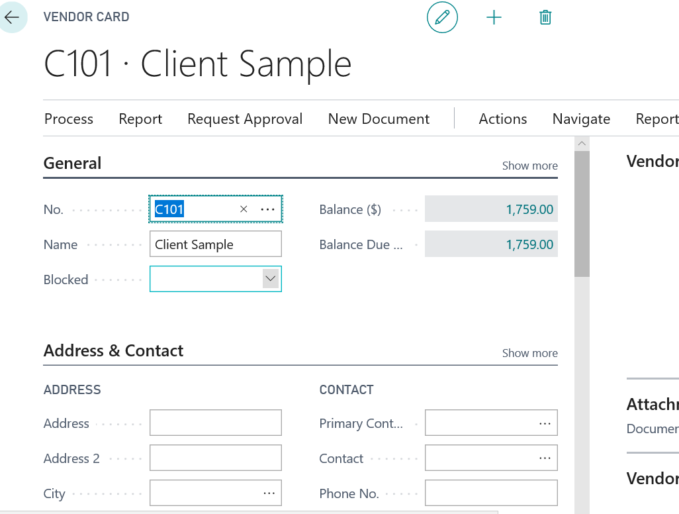

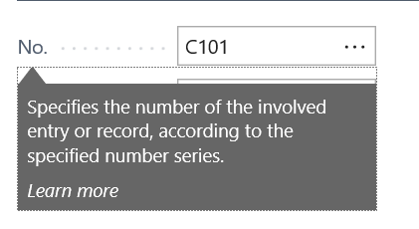

Clicking on the name of a specific field provides you with more information regarding the field.

Keyboard Shortcuts

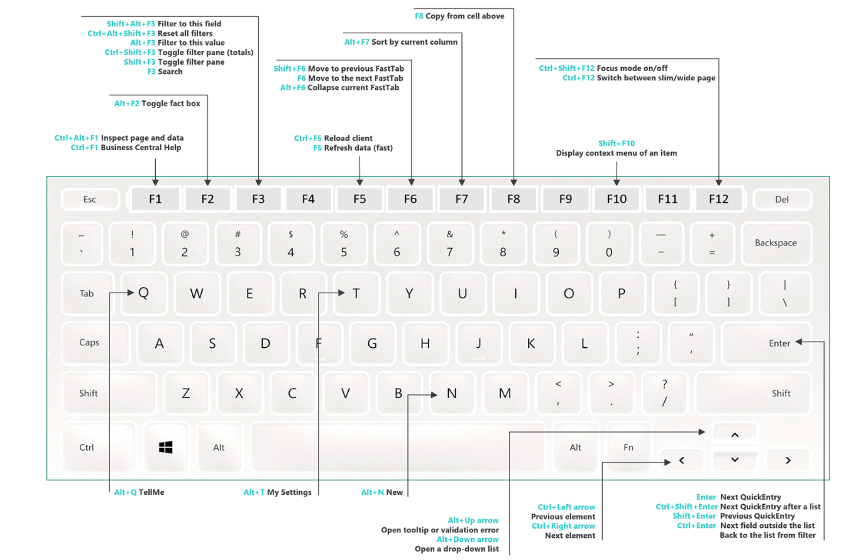

Interface Entities
Note that the term ‘page’ is used when describing interfaces in BC

“Tell Me to” Find Feature

Tell Me helps you quickly go to things like actions, pages, or reports, find information about how to complete a particular task, and discover additional apps and consulting services for Business Central.

Business Central is broken down into Lists, Tasks, Reports & Analysis.

When you need help finding something, use the Tell me what you want to do icon to search for it. You can also use ALT+Q to start using Tell Me.

When you start typing characters, Business Central immediately displays matches. Results in the list change as you type more characters. If you notice that when you enter the word "product" and the results include "items," that's because Tell Me uses synonyms and alternate search terms to make it easier to find actions, pages, and reports.

The Tell me what you want to do function does not search for data, such as customer names, addresses, or transactions. Instead, you can search for data in list pages by choosing the Search icon 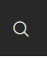 in the left corner of the list header. The search applies only to the list you are viewing.

The column to the right indicates the general category of the result. For example, whether it will open a list page or is an administrative task.

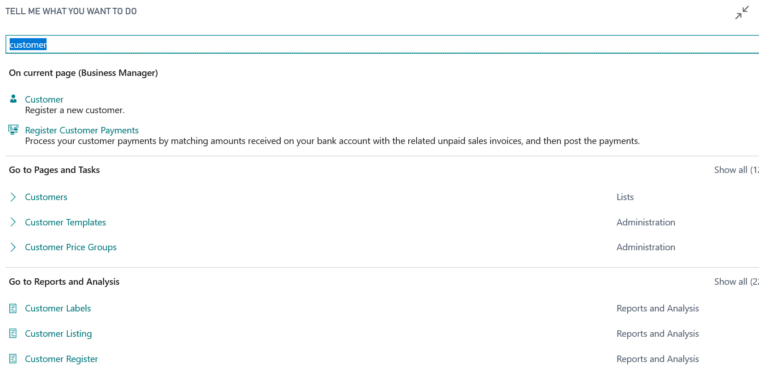

Find an Action on the Current Page

The On Current Page section lets you find and perform actions on the page you have open. For example, if the Sales Quote page is open and you type "customer," the section includes an action that opens the customer card for the customer chosen on the sales quote.

Find a Page or a Task

The results in the Go to Pages and Tasks section provide access to other pages and let you perform tasks. The pages and tasks that are listed depend on the user experience you chose for your company.

Find a Report or Archived Information

The Go to Reports and Analysis section offers access to reporting tools. For example, you can open the Balance Sheet report from the list, or access archived documents and other information.

Under Documentation you will see articles from the Business Central documentation that describe concepts and provide step-by-step guidance for completing tasks in the application.

Personalizing Your Workspace

How to personalize a page
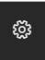
- In the upper-right corner, select the icon, and then choose Personalize.

The Personalizing banner appears at the top to indicate that you can start making changes.
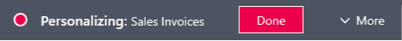

- Go to a page that you want to personalize.
If you see a or in the banner, you cannot personalize the page.

Point to an area that you want to personalize, such as a field or column header in a list. Anything that you can personalize is immediately highlighted with an arrowhead or border.

- You can continue to make changes on the same page or open another page. Your changes are automatically saved as you make them. When you are done, in the Personalizing banner, choose Done.

What You Can Personalize

Move something, like a field, column in list, tile, action, or part | Point anywhere on what you want to move and drag it to its new location. The location is indicated by either a thick horizontal or vertical line.  indicates that you cannot move the element to the selected location. | Parts are subdivisions or areas on a page that contain things like multiple fields, another page, a chart, or tiles.

Hide something, like a field, column in list, tile, or part. | Select the arrowhead and choose Hide. | If the field you hide is also shown in the FastTab heading when the FastTab is collapsed, the field will no longer appear there.

Add a field or column. | In the Personalizing banner, choose More, and then choose Field.  The Add Field to Page pane opens on the right. It lists the fields that you can add to the page.  To add a field, drag it from the pane to the location that you want it. The location is indicated by either a thick horizontal or vertical line. | Each page includes a predefined set of fields that you can display. Use this procedure to add fields or columns that have not been previously displayed or to show fields that you have hidden.

Display a field in the heading of a Fastab when the FastTab is collapsed. | Select the arrowhead and choose Show when collapsed.  If you do not see this option, then it is already set. In this case, to stop displaying the field in the FastTab heading, choose Show always. | FastTab is the term used for a group of fields that appear under a common heading. Use the Show when collapsed option to display the most important fields. If you select a field in the heading, the FastTab will open and focus on the selected field.  This option is only applicable if a page has a more than one FastTab. If the is only one FastTab, it cannot be collapsed, so the Show when collapsed option is not available.

Make a field display only when you select Show more. |  | Select the arrowhead and choose Show under "Show More".  If you do not see the Show under "Show More" option, then it is already set. In this case, to make a field display always, not just when you select Show more, choose Show always.
Change the freeze pane in a list to another column. | Select the arrowhead of the column that you want as the last column of the freeze pane, and then choose Set Freeze Pane.  If you want to set the freeze pane back to its original designed location, select the arrowhead for the current freeze pane column, and choose Clear Freeze Pane. Note: You cannot remove this freeze pane. |  | The freeze pane specifies the columns that always appear on the left, even as you scroll horizontally.

Change the width of a column. | In the table header row, drag the column's right border.  To maximize the column width to fit the longest line of text in the column, double-click the right border.

Skip over a field when pressing Enter. | Select the arrowhead next to the field, or column heading in a list, and choose Exclude from Quick Entry.  If you do not see this option, then the field is already set to be skipped. In this case, to stop skipping the field, choose Include in Quick Entry.

Personalizing Actions

You can personalize the action bar that is located at the top of the page.

When you make changes to a card page that you open from a list, the changes will take effect on all records that you open from that list. For example, let's say you open a specific customer from the Customers list page, and then personalize the page by adding a field. When you open other customers from the list, the field that you added will also be shown.

Changes that you make will take effect on all your Role Centres. For example, if you make a change to the Customer list when the Role Centre is set to Business Manager, you will also see the change in the Customer list when Role Centre is set to Sales Order Processor.

Changes to a page in a pane will take effect on the page where ever it is shown.
You can only add fields and columns from a predefined list, which is based on the page. You cannot create new ones.

Personalization lets you decide which actions to show on the action bar and where to show them. You can show, hide, or move individual actions or action groups. Personalizing the action bar is done basically the same way as with other elements of the workspace. However, exactly what you can do with an action or group depends on where the action or group is located in the action bar. The best way to find out is to just try things out and let the screen guide you. The following sections will explain some of the nuances of personalizing the action bar.

Action Bar Overview

What is an Action Group: it is item that expands to display other actions or groups. For example, in the following illustration, Posting is an action group.

What is a Promoted Category: it is an action group that appears between the two vertical lines | in the action bar. The categories typically include the most commonly used actions, so that you can quickly find them. For example, in the following illustration, Release, Posting, Invoice, and Navigate are promoted categories.

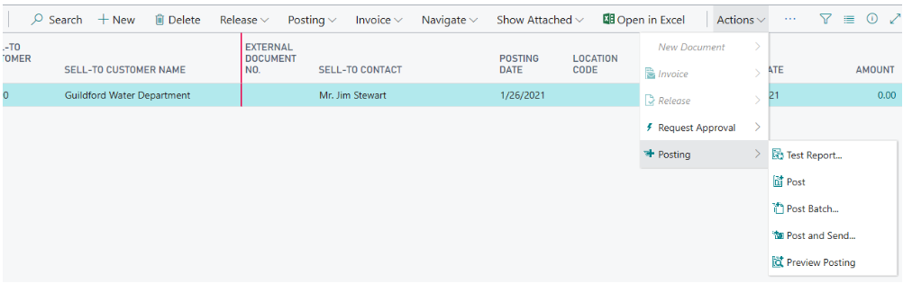

To remove, hide, and show actions and groups

To show or hide and action or action group, select it, and then choose from one of the following options:

Option | What it does
Remove | This option appears if the selected action is also shown somewhere else in the action bar. Choosing this option deletes the action from the selected location so that it no longer appears. The action or action group will remain in the other locations.
Hide | This option appears if the action or action group is not located anywhere else in the action bar. Like Remove, choosing this option will make the action or action group disappear from the action bar. However, in the personalization mode, the action or action group will still be shown in the current location, except that it appears dimmed.
Show | This option appears if the action or action group has been previously hidden (dimmed). Choosing this option will make the action or action group appear in the action bar.

To move actions and action groups

To move an action or action group, drag and drop it to the desired location, just like with fields and columns.

Where you can drop actions or action groups is indicated by a horizontal line between to actions or border around an action group.

- You can move individual actions into the promoted categories, but you cannot rearrange the order of the actions in the category.
- You cannot move an action group into a promoted category.
- To move an action or action group into another action group that is empty, drag the action or action group to the new group and drop it in the Drop an action here box.

To clear personalization

At some point, you might want to undo some or all of the personalization changes that you have made to a page over time. To do this, in the Personalizing banner, choose More, Clear Personalization, and then choose one of the following options. Be aware that clearing personalization cannot be undone.

Option | What it does
Only Actions | Clears any personalization changes that you have ever made to action bar on the page.
All Except Actions | Clears any personalization changes that you have ever made to the page except those in the action bar. This includes changes to fields, columns, parts, and tiles.
All | Clears all personalization changes that you have made to the page to the page so it looks like it did originally. This includes changes to action bar, fields, columns, parts, and tiles.

Sorting, Searching, and Filtering Lists

Sorting

Sorting makes it easy for you to get a quick overview of your data. If you have many customers, for example, you can choose to sort them by Customer No., Customer Posting Group, Currency Code, Country Region Code, or Sales Tax Registration No. to get the overview you need.

To sort a list, you can either choose a column heading text to toggle between ascending and descending order or choose the small down arrow in the column heading, and then choose Ascending or Descending.

Searching

At the top of each list page, there is a Search icon that provides a quick and easy way to reduce the records in a list and display only those records that contain the data that you are interested in seeing.

To search, simply select the search icon, and then in the box, type the text that you are looking for. You can enter letters, numbers, and other symbols.

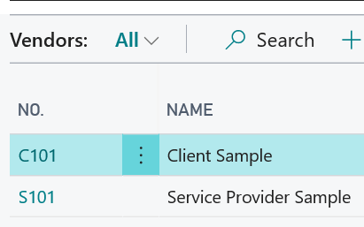

Fine-tune the Search

In general, search will attempt to match text across all fields; it does not distinguish between uppercase and lowercase characters (in other words, case insensitive), and will match text placed anywhere in the field (at the beginning, end, or in the middle).

However, you can make a more exact search by using the following special characters:

- To find only field values that match the entire text and case exactly, place the search text between single quotes '' (for example, 'man').
- To find field values that start with a certain text and match the case, place * after the search text (for example man*).
- To find field values that end with a certain text and match the case, place * before the search text (for example *man).
- When using '' or *, the search is case sensitive. If you want to make the search case insensitive, place @ before the search text (for example @man*).

See Example Searches

Search Criteria | Finds...
man  or  Man | All records with fields that contain the text man, regardless of the case. For example, Manchester, manual, or Sportsman.
'Man' | All records with fields that contain only Man, matching the case.
Man* | All records with fields that start with the text Man, matching the case. For example, Manchester but not manual or Sportsman.
@Man* | All records with fields that start with man, regardless of the case. For example, Manchester and manual, but not Sportsman.
@*man | All records that end with man, regardless of the case. For example Sportsman, but not Manchester or manual.

Filtering

Filtering provides a more advanced and versatile way of controlling which records display in a list. There are two major differences between searching and filtering, as described in the table below.

 | Searching | Filtering
Applicable fields | Searches across all fields that are visible on the page. | Filters one or more fields individually, selecting from any field on the table, including fields that are not visible on the page.
Matching | Displays records with fields that match the search text, irrespective of casing or placement of that text. | Displays records where the field matches the filter exactly and is case sensitive, unless special filter symbols are entered.

Filtering enables you to display records for specific accounts or customers, dates, amounts, and other information by specifying filter criteria. Only records that match the criteria are displayed. If you specify criteria for multiple fields, then only records that match all criteria will be displayed.

Working in the Filter Pane

To display the filter pane, select at the top of the list or press Shift+F3. For lists within the Role Centre, you can also choose the down arrow near the page title in the navigation bar above the list, and then choose Show filter pane as shown here:

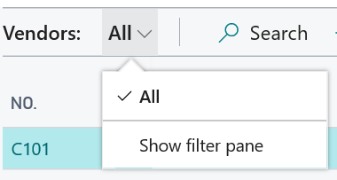

The filter pane displays the current filters for a list and enables you to set your own custom filters on one or more fields.

A filter pane is divided in three sections: Views, Filter list by, and Filter totals by:

• Views

Some lists will include the Views section. Views are variations of the list that have been preconfigured with filters. To switch to a different view of your list, simply select another link. You can temporarily change the filters on a view, but the changes will not be permanently saved.

• Filter list by

The Filter list by section is where you add filters on specific fields to reduce the number of displayed records. To add a filter, select + Filter, select the field that you want to filter from any field in the table, and then enter filter criteria in the box.
• Filter totals by

Some lists that display calculated fields, such as amounts and quantities, will include the Filter totals by section where you can adjust various dimensions that influence calculations. For example, you can quickly analyse your chart of accounts by filtering amounts to a specific period, or you can view the totals for sales orders only from a specific warehouse.

To add a filter, select + Filter, select one of the predefined dimensions, and then add the filter criteria in the box.

Entering Filter Criteria in the Filter Pane

To select a field to filter, do one of the following:

- In the filter pane, choose + Field. Type the name of the field you wish to filter or pick a field from the menu that displays all fields in the table.
- In a column heading, choose the down arrow, and then choose Filter.... This will open the filter pane and add the column to the filter pane.

You can now type or select your filter criteria in the box. The type of field you filter determines which criteria you can enter. For example, filtering a field that has fixed values will only let you choose from those values.

Columns that already have filters are indicated by the in the column heading. To remove a filter, select the column heading, then choose Clear Filter.

Entering Filter Criteria Without Using the Filter Pane

You can specify simple filters directly within the list without having to use the filter pane. With any field selected on a row, use the Alt+F3 keyboard shortcut to display only the records having that same value. You can then select another field and use the same shortcut again to continue refining your filters. If the selected field is already filtered, using Alt+F3 will clear that filter.

Filter Criteria and Symbols

When you enter criteria, you can use all the numbers and letters that you can normally use in the field. In addition, you can use special symbols to further filter the results. The following tables show the symbols which can be used in filters.

Filter Criteria and Symbols
Sample Expression | Display
(..) Interval
1000..2000 | Numbers 1000 through 2000
..2500 | Numbers up to 2500
..12 31 19 | Dates up to and including 12 31 19
P8.. | Information for accounting period 8 and after
..23 | Date field - dates up to and including 23 of current month in current year
23.. | Date field - dates from 23 of current month in current year to the end of time
22..23 | Date field - dates 22nd and 23rd of current month and current year
(|) Either/Or/And
10|25 | Numbers 10 and 25
(<>) Not Equal to
<>0 | All numbers except 0
<>B* | Not equal to any text that starts with B
(>) Greater Than
>100 | Numbers greater than 100
(<) Less Than
<2500 | Numbers less than 2500
(>=) Greater than or Equal to
>=15 | Numbers greater than or equal to 15
(>=) Less than or Equal to
<=2000 | Numbers less than or equal to 2000
(&) And
>55&<100 | Numbers greater than 55 and less than 100
('') An Exact Character Match
booth' | Text that matches booth exactly and is case sensitive
(@) Case Insensitive
@booth* | Text that starts with booth and is not case sensitive
(*) An Indefinite Number of Unknown Characters
*We* | Text that contains "We" and is case sensitive
*We | Text that ends with "We" and is case sensitive
We* | Text that begins with "We" and is case sensitive
(?) One Unknown Character
Park?r | For example text Parker or Parkur
Combined Formats
65|800..900 | Number 65 and all numbers 800 to 900 inclusive
..230|300.. | Numbers up to and including 230 and all numbers 300 and greater - excluding 231-299

Filter Tokens

When entering filter criteria, you can also type words that have special meaning, called filter tokens. After entering the token word, the word is replaced by the value or values that it represents. This makes filtering easier by reducing the need to navigate to other pages to look up values you want to add to your filter. The tables below describe some of the tokens you can type as filter criteria.

(%me or %userid) Records Assigned to You

Use %me or %userid when filtering fields that contain the user ID, such as Assigned to User ID field, to display all records that are assigned to you.

(%mycustomers) Customers in My Customers

Entering Data

Data Entry Using Quick Entry Accelerates the Process

Quick Entry works on fields (like on card pages) and in lists (rows and columns). It is beneficial when performing repetitive typing tasks that require creating multiple records in sequence, such as a batch of sales orders or registering new items.

The Tab key allows you to navigate from one field on a page to the next editable field. A disadvantage of using Tab is that it always goes sequentially to the next field. Quick Entry lets you change this path. With Quick Entry, you use the Enter key to navigate through only those fields that you are interested in, skipping non-editable fields and fields that you typically do not fill in. The application already designates which fields to include when pressing Enter and which ones to skip. You can customize Quick Entry by personalizing your workspace and optimizing how you enter data on each page.

Every field can be marked as either being included in Quick Entry or excluded from Quick Entry. Fields that are included in Quick Entry, will be included in the path when you press Enter; fields that are excluded from Quick Entry, will not.

When you are finished entering data in a field, you simply press Enter to confirm the changes and go to the next field. If you want to reverse direction, and go the previous field, press Shift+Enter.

Tips and tricks

- It is available for any editable fields.
- It also works across columns and rows.
- It does not prevent accessing other elements of a page, such as actions. These are still accessible by using Tab and Shift+Tab.
- FastTabs do not have to be expanded for Quick Entry to work. If the next Quick Entry field is located in a collapsed FastTab, that FastTab will automatically expand and focus on the designated field.
- Quick Entry works irrespective of whether fields are mandatory. It is a good idea to ensure that mandatory fields are included in Quick Entry.
- By default, most fields are automatically included in Quick Entry. So initially your task will most likely be excluding fields from Quick Entry.

How to Change Quick Entry Fields

To change which fields are included in or excluded from Quick Entry on a page, you use personalization.

- Start personalisation by selecting the icon, and then Personalize.

- Select a field that you want change, or in lists, select the corresponding column heading, and then choose either Include in Quick Entry or Exclude from Quick Entry.

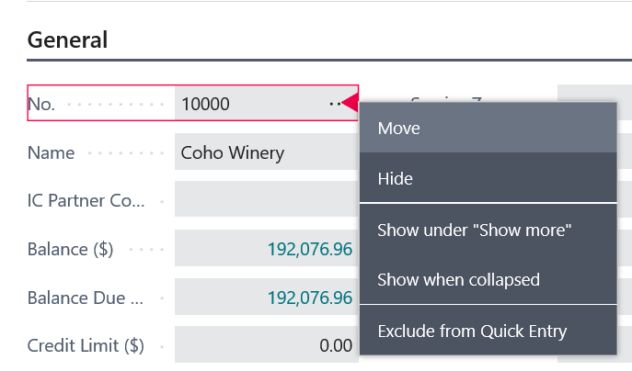

Mandatory Fields

When you enter data on pages, certain fields are marked with a red asterisk. The red asterisk means that the field must be filled to complete a certain process that uses the field, such as posting a transaction that uses the value in the field.

Even though the field contains a red asterisk, you are not forced to fill the field before you continue to other fields or close the page. The red asterisk only serves as a reminder that you will be blocked from completing a certain process.

Finding Data As You Type

When you start to type characters in a field, a drop-down list is displayed and shows possible field values. The list changes as you type more characters, and you can select the correct value when it is displayed.

Many fields have a down arrow button that you can choose. You choose the arrow to get a list of data that is available to enter in the field. The button has two functions depending on the type of field:

- Lookup - Displays information from another table that you can enter in the field. You can select one piece of data at a time.
- Drop-down - Displays the set of options that exist for the field. You can select only one of the options.

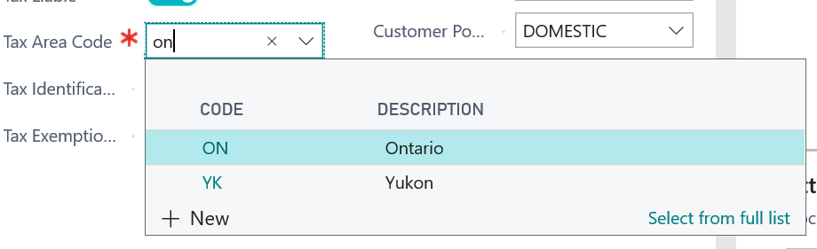

Focus on Lines
If you’re working in a document that has lines such as a sales order or invoice page, you can change your view to focus only on the line items, to allow for easier data entry by having this section take up more of the page and this hides the other parts of the page This is helpful when working with large line item lists.

It also provides advanced filtering capability.

Switch the Focus On and Off
To focus on lines items, select anywhere in the line item part, and then choose in the upper right corner or press Ctrl+Shift+F12. To switch back to the normal view, choose or press Ctrl+Shift+F12 again.

Before switching Focus – Sales Order Example

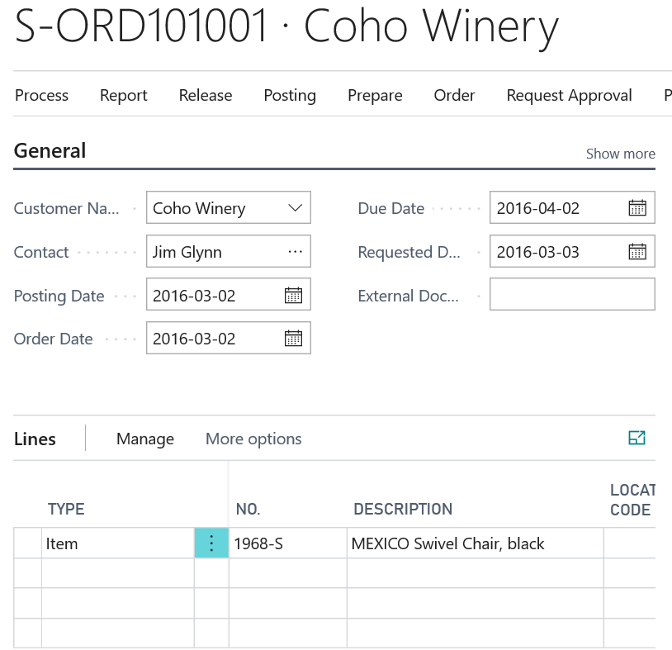

After switching Focus

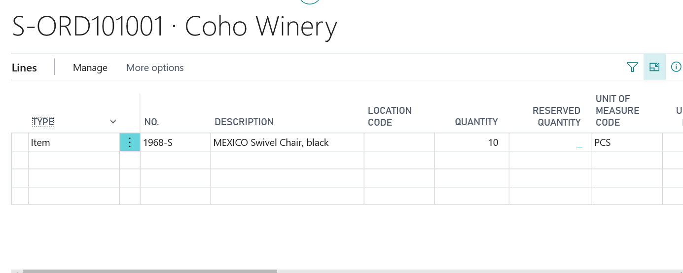

Filtering the Line Items
To start filtering, select at the top of the list or press Shift+F3 to open the filter pane. You work with the filter pane as you do on any other list.

Filtering is especially helpful when viewing and analysing longer documents. For example, imagine you open a posted sales invoice and filter the line items to display all line items that have ATHENS in the name.

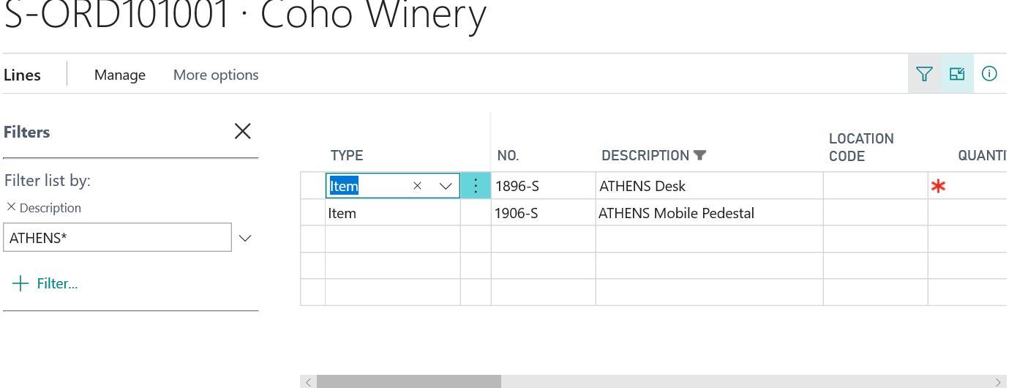

Entering Quantities by Calculation

When entering numbers into quantity fields, such as the Quantity field on an item journal line, you can enter the formula instead of the sum quantity.

Business Central will allow you to enter calculations within fields.

For Example in a quantity field:

If you enter 10 + 10 the value will populate as 20
If you enter 30-15 the value will populate as 15
If you enter 2*6 the value will populate as 12
If you enter 12/6 the value will populate as 2

Entering Dates

For date fields, you can use the data picker to select from a calendar view or you can enter dates manually.

For manually date entry, you do not have to enter all eight digits:
- If you enter only the digits related to the day for example 12 the system will automatically fill in the month and year. This works if you are entering a day in the current month and year.
- If you enter the digits that represent the day and month for example 1205 the system will automatically fill in the year. This works if you are entering a day/month in the current year.
- If the date you want to enter is in the range 01/01/1930 through 12/31/2029, you can enter the year with two digits; otherwise, enter the year with four digits.

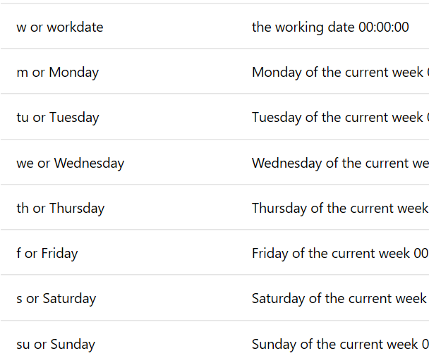

Copying and Pasting

What you can copy

- Copy one or more rows in Business Central to the same list, or to any list with identical columns.
- Copy one or more rows in Business Central and paste into Excel or other applications.
- Copy one or more rows in Excel and paste into a Business Central list.
- Copy the value of an individual field in Business Central and paste it anywhere.

Lists that you can copy and paste rows

You can copy rows in any kind of list, including worksheets, FactBoxes, or list that are embedded on a page (like lines of a sales order). However, to paste rows, the list must be editable.

How to copy rows

To copy a single row, select it, and press Ctrl+C.

If you want to copy more rows, you can:
- Press Ctrl+Click on another row or press Shift+Click to select the row and all rows in between.
- Select in the first column of a row, choose Select More, select the check box next to each row that you want to copy, and then press Ctrl+C.

How to paste rows

Select an empty row, and press Crtl+V. If you want to replace existing rows, select the rows and press Crtl+V. In this case, you can only paste the same number of rows that you selected.

You must have the exact same number of columns when pasting rows

Whether you are copying from Business Central, from Excel, or from some other table source, the rows that you paste must have the exact matching columns - no more no less.

Errors when pasting rows

When pasting into Business Central, each row is checked to make sure that values in each column are valid. If a column contains a value that is not valid, the pasting is stopped, and an error message is displayed. To avoid this, make sure that the columns have valid values before you paste them.

Viewing and Editing in Excel From Business Central

With pages that display a list of records in rows and columns, like a list of customers, sale orders, or invoices, you can also view the records using Microsoft Excel. To do this, you have two options. You can either select the Open in Excel action or the Edit in Excel action on the page.

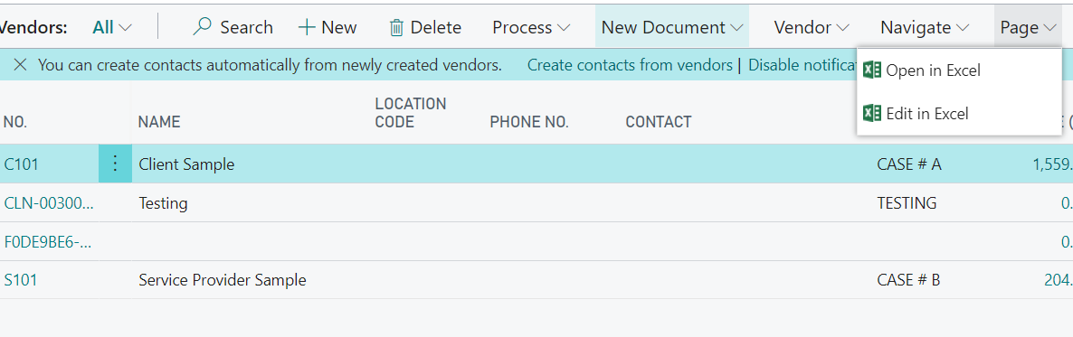

The differences between the two actions is as follows:

Open in Excel

Excel respects any filters on the page the limit the records shown. This means that the Excel workbook will contain the same rows and columns that appear on the page in Business Central.

You can make changes to the records in Excel, but you cannot publish the changes back to Business Central. You can only save the changes to Excel file on your computer.

Edit in Excel

The Excel workbook does not respect filters on the page the limit the records shown. This means that the Excel workbook will contain all the available records and columns, regardless of what is shown on the page.

The advantage of the Edit in Excel action is that it lets you make changes to records in Excel and then publish the changes back to Business Central.

Managing Notifications

Business Central allows you to have the ability to be notified about certain events or changes in status, such as when you are about to invoice a customer who has an overdue balance. These notifications are shown as discreet tips in the context of the task you are doing, and you can choose to ignore the notification or to see details about the issue.
I
If you choose to see details for a notification, you can take action to resolve the issue, such as contacting the customer. It's your choice what to do, and Business Central gives you advice and recommendations.

Notifications can help untrained users complete unfamiliar tasks, and do not reduce productivity for the more trained user.

To turn notifications on or off, and control when they are sent

All notifications are turned ON when you first start with Business Central, but you can turn them on or off, for example, if you aren't interested in a certain event or status.

Additionally, some notifications let you specify the conditions under which they are sent.

Turning notifications on or off, and specifying conditions, applies only to you.

- Choose the icon, enter My Notifications, and then choose the related link.
- To turn on or turn off a notification, select or clear the Enabled check box.
- To specify conditions that trigger a notification, choose the View filter details link, and then fill in the fields.

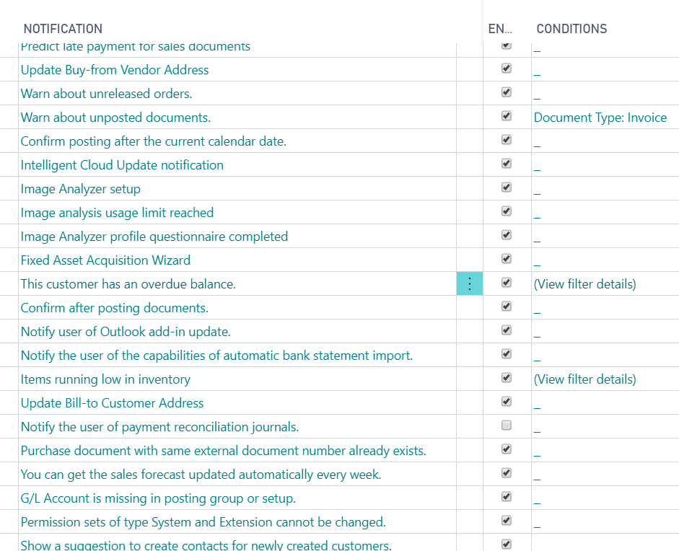

Working With Reports

Specifying the Data to Include in the Report

When you open a report, you are typically presented with a page where you set various options and filters that determine what to include in the report. This page is called the report request page. For example, the report request page lets you create a report for a specific vendor, a certain date range, or sort the order of information in the report.

Here is an example of a report request page:

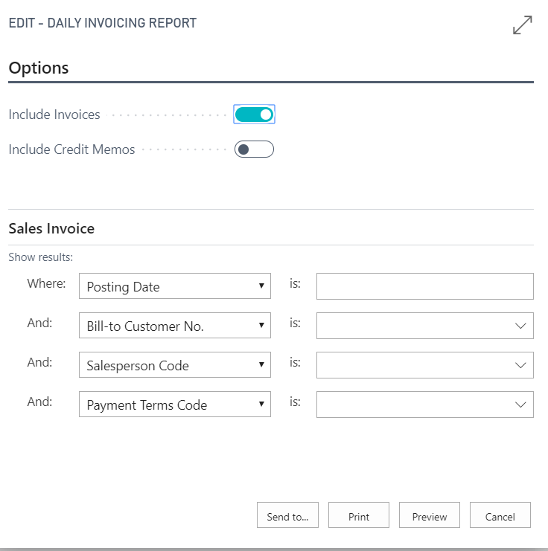

You can add more filters by filling the And and is boxes. When you have more than one filter, only results that meet the criteria for all filters will be included in the report.

Depending on what type field you are filtering, you can specify the filter criteria to look for an exact match, partial match, range of values, and more.

See Filter Criteria section of this document for tips on how to filter

Using Saved Settings

With some reports, depending on how they are designed, the report page might include the Saved Settings section that contains one or more entries in the Use default value from box. The entries in this box are called saved settings. A saved setting is basically a predefined group of options and filters that you can apply to the report before previewing or sending the report to a file. The saved settings entry called Last used options and filters is always available. This entry sets the report to use options and filters that were used the last time you looked at the report.

Using saved settings is a fast and reliable way to consistently generate reports that contain the correct data. After you set the Use default value from box to a saved settings entry, you can change any of the options and filters before previewing or saving the report. The changes that you make will not be saved to the saved settings entry you selected, but they will be saved to the Last used options and filters.

Previewing a Report

Choose Preview to see the report in the Internet browser. Point to an area of the report to show the menu bar.



Use the menu bar to:

- Move through pages
- Zoom in and out
- Resize to fit the page
- Select text
You can copy text from a report, and then paste it somewhere else, like a page in Business Central or Microsoft Word. Using a mouse, for example, you press and hold where you want to start, and then move the mouse to select one or more words, sentences, or paragraphs. You can then press the right mouse button and select Copy. You can then paste the selected text where ever you want it.
- Pan the document
You can move the visible area of the report in any direction, so you can view other areas or the report. This is helpful when you have zoomed in to see details. Using your mouse, for example, press and hold the mouse button anywhere in the report preview, and then move your mouse.
- Download to a PDF file on your computer or network.
- Print

Scheduling a Report to Run

You can schedule a report to run at a specific date and time. Scheduled reports are entered in the job queue and processed at the scheduled time, similar to other jobs. You can choose to save the processed report to a file, such as an Excel, Word, or PDF, print it to a selected printer, or process the report only. If you choose to save the report to a file, then the processed report is sent to the Report Inbox area on your Role Centre, where you can view it.

You can schedule a report when you open a report. You choose the Schedule action and then you enter information such as printer, and time and date. The report is then added to the job queue and will be run at the specified time. When the report is processed, the item will be removed from the job queue. If you saved the processed report to a file, it will be available in the Report Inbox area.

Add Comments to Cards and Documents

You can add extra information to G/L accounts, customers cards, or sales orders to communicate exceptions or special agreements to other users. Practically all cards and document have a Comments action, which opens the Comment Sheet page where you can write or read comments. On documents, you can also add comments to individual lines.

To add a comments to an item card

- Choose the icon, enter Items, and then choose the related link.
- Open the relevant item card.
- Choose the Comments action.
- On the Comment Sheet page, enter any text, and then choose the OK button.

Send Documents by Email

You can email practically all document types as attachments to email messages directly from the page that shows the document. In addition to the attachment, you can set up document-specific email bodies with core information from the document preceded by standard text that greets the mail recipient and introduces the document in question.

From all supported documents, you initiate emailing by choosing the Send action, on posted documents, or the Post and Send action, on non-posted documents.

If the Email field on the Send Document to page is set to Yes (Prompt for Settings), then the Send Email page opens prefilled with the contact person in the To: field and the document attached as a PDF file. In the Body field, you can either enter text manually or you can have the field filled with a document-specific email body that you have set up.

New Enhanced Email Functionality

See additional documentation

NOTES

NOTES

